**REPORTS**

**NAME CHOOSEN BY STUDENTS:**

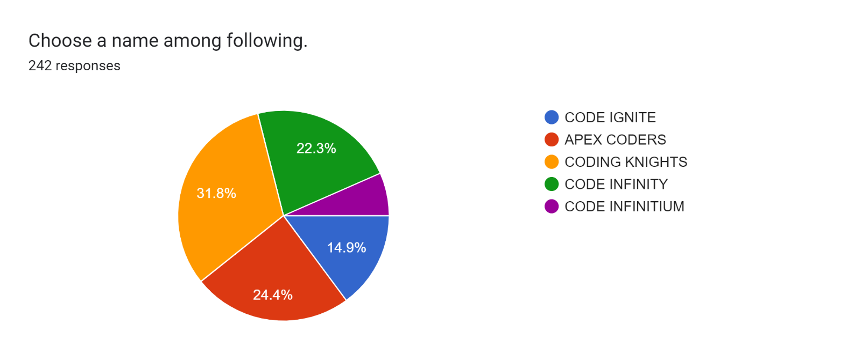

**Other names being suggested:**

1. Code Era
2. CODING KINGS
3. Coderzz BEC
4. Code inferrers
5. BECS - BEC Code Stack
6. Coders Brigade
7. Pheonix Coding Club
8. Techies
9. Code crackers
10. Just Code
11. GreedyCoders
12. BEC code crusaders or just code crusaders
13. Live to code
14. CODING BUGS
15. It was a coding club so errors were common so the name was "THE ERRORS"
16. CODE WARS
17. CODE BREAKER
18. Coding Ninjas
19. Saadhan is the new name and it is different.As the name always suggests learning
20. Saadhan as it indicates always learning..
21. 1)Error Makers 2)Royal Code Masters (RCB)
22. CODING HUB/CODE HUB
23. Coding SPOT
24. Code magic
25. Funky Coders
26. ROYAL CODE CRACKERS
27. Codeverse
28. CODING KILLERS
29. Elite Coders
30. Nothing
31. CODING RIDERS
32. CODING MONKS
33. CODING BLISS (BLISS means great joy or happiness)
34. Code need
35. while-1 coders, for-each coders, while-true coders, ++ coders, coders++,
36. Code crackers
37. Code wars
38. CODEXIVE
39. MIC(Masters In Coding)
40. CodeEase - This name suggests that the club is focused on helping members relax and destress while learning and practicing coding, and could imply a sense of calm and focus.
41. Amateur coders
42. Saadhan code
43. Hacker coders
44. Theme Coders
45. saadhan
46. Coder's plaza
47. Coding Metaverse
48. Code infinitum
49. Py.waz, Jawaz
50. Cogent coders
51. Code Hunters / Code Career / Runtime Terror /Code Era
52. bec patterbrain codders,bec codder techie's
53. Cogent coders
54. decoders
55. Code Crackers
56. Alpha
57. CODE LIGHTS
58. Dynamite coding
59. Code Anonymous
60. Saadhan
61. Code chasers
62. Coding knights
63. Code_Breaker or Coding_Cats
64. Anonymous coders or code crackers
65. Learn code skill
66. Achievers
67. Innovative coders
68. Code stack
69. Mark the Error, Language legacy, Bit by Bit. Although the above mentioned names are good enough, it is suggested to nomenclate with the different sound!!!
70. SAADHAN